Development of Virtual lab :Round 1 (R1) Pedagogy - Template (Worksheet)

|  |
| --- |
| **Name of Faculty:**Ajay Kumar Dhanopia  **Institute**:Swami Keshvanand Institute of Technology, Jaipur  **Email ID** (as submitted in the registration form)**:** ajaydhanopia123@gmail.com  **Discipline to which the Lab belongs:** Mechanical  **Name of the Lab:** Material Science & Testing (MST)  **Name of experiment :**To study the spring testing machine and Determine the design parameters for tension and compression helical spring.  (only one Experiment per worksheet. for submitting more than one experiments, please fill up another worksheet)**:**  **Kindly Refer these documents before filling the worksheet**   1. **Coursework (MOOC ) on Pedagogy , Storyboard , Lab Manual :** [**http://bit.ly/Vlabs-MOOC**](http://bit.ly/Vlabs-MOOC) 2. **Additional Documentation booklet for reference.**[**http://vlabs.iitb.ac.in/vlabs-dev/document.php**](http://vlabs.iitb.ac.in/vlabs-dev/document.php) 3. **Sample Git Repository. :** |

* 1. **FOCUS AREA:**

Any elastic member which can deform under a force can act as a spring. The main function of a spring is to a deflect under a load and to recover the original shape when the load is released. Helical compression spring may be expanded to twice its length without losing its elasticity. Basically need to focus about how spring material behaves by applying absorb shock or impact loading as like in to store energy as in clock springs, to apply forces to and to control motions as in brakes and clutches and to measure forces as in spring balances.

* 1. **About the Experiment:**

The virtual experiment consists of several tabs which are- theory,procedure,self-evaluation, simulator, quiz, videos and reference.

Theory : it consists of the concepts which are necessary for any students to know before performing the experiment virtually.

Procedure: it consists all the steps which are to be followed while performing the experiment.

Self-evaluation: it consists of pre experiment questions. These questions helps the student to refresh his/her knowledge of the concepts which are going to be used in the virtual experiment.

Simulator: This is the main part of the virtual experiment. Here the student performs the experiment and observe the working of the machine through simulations.

Quiz: This is the post experiment quiz, it tests the understanding of the student about the experiment.

Videos & reference: Here, student could find the videos and the reference books which are useful for more information on the topic.

**1.3 Learning Objectives:**

Write Learning Objectives that can be achieved using virtual labs and the respective cognitive level, & action verbs.

|  |  |  |  |
| --- | --- | --- | --- |
| **S.No.** | **Learning Objective** | **Cognitive Level** | **Action Verb** |
| 1. | To know about the terminologies used in the designing of spring. | Level-1 | Define |
| 2. | To know the working and construction of the universal spring testing machine. | Level-1 | Understand |
| 3. | To perform the experiment virtually. | Level-1 | Perform & Apply |
| 4 | To analyze the data obtained while performing experiment. | Level-2 | Analyze |

(you can add more rows. )

**2. Instructional Strategy**

Here we are using expository method of instructional strategy.

When the user opens the experiment, he/she reads and understands the theory, after that he/she see the procedure through which he have to perform the experiment.

In the simulator part he/she performs the experiment and analyzes the result obtained.

There are pre and post assignment quizzes which tests the knowledge of the student.

**2.1 Instructional Strategy:**

The brief description of the steps followed by the user to perform experiment virtually:

Theory =>Procedure => Self-evaluation (pre experiment quiz) =>Simulator => quiz(post experiment quiz) => videos & reference

**2.2 Assessment Method:**

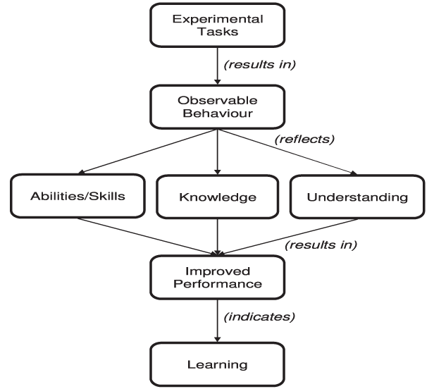

**2.3 Description of sections:**

1) Theory: It consists of the concepts which are necessary for any students to know before performing the experiment virtually.

2) Procedure: it consists all the steps which are to be followed while performing the experiment.

3) Self-evaluation: it consists of pre experiment questions. These questions helps the student to refresh his/her knowledge of the concepts which are going to be used in the virtual experiment.

4) Simulator: This is the main part of the virtual experiment. Here the student performs the experiment and observe the working of the machine through simulations.

1. Task 1: measure the outer diameter of the spring.
2. Task 2: measure the internal diameter of the spring.
3. Task 3: fix the spring on the machine.
4. Task 4: close the pressure valve.
5. Task 5: Apply load on the spring
6. Task 6: observe calculations and results.

5) Quiz: This is the post experiment quiz, it tests the understanding of the student about the experiment.

6) Videos & reference: Here, student could find the videos and the reference books which are useful for more information on the topic.

**3. Task & Assessment Questions**

Complete the following table with details of the various tasks and assessment questions you will give to the students.

( you can add more rows. Assessment Questions to all the Learning Objective should be met. )

|  |  |  |  |
| --- | --- | --- | --- |
| **SrNo.** | **Learning Objective to be met**  (choose anyone from you declared above) | **Tasks to be performed by the students** | **Assessment questions aligned to the task** |
| **1** | Know the use of vernier caliper. | Measure outer diameter of the spring. | Which instrument is used to measure the diameter of the spring ? |
| **2** | Know the use of vernier caliper. | Measure the internal diameter of the spring. | What would be the mean effective diameter and the diameter of the spring wire ? |
| **3** | Know the position of the spring | Fix the spring on the machine. | Where we would fix the tensile spring on the machine ? |
| **4** | Use of pressure valve and hydraulic system. | Close the pressure valve. | Why we close the pressure valve? |
| **5** | Effect of applying load on the spring | Apply the load on the spring | What is effect of applying load on the spring? |
| **6** | Analyze the formulas and calculations involved. | Observe the calculations involved and analyze the result. | What are the formulas used in the calculations?  What can you conclude from the experiment? |

**4. Simulator Interactions**

**Complete the following table giving the details of the Simulator interactions.**

|  |  |  |
| --- | --- | --- |
| **What students will do?** | **What simulator will do?** | **Purpose of the task** |
| Select the experiment and click on the Vernier caliper . | Move the Vernier caliper to the spring and measure the outer and inner diameter of the spring. | To measure the inner and outer diameter of the spring. |
| Click on the spring to fix it on the spring  . | Move the spring and fix it to the machine and ready for the experiment. | To fix the spring on the machine for testing. |
| Click on the rotating valve to close the pressure valve. | Rotate the wheel to show that the valve is closing. | To close the pressure valve inside the machine because the machine is based on the hydraulic system. |
| Push the up button to set the load. | It lifts the bars and compress the spring according to the experiment chosen and also rotates the dial to show the applied load. | To set the load and perform the experiment. |